**Module-8: Jenkins Assignment – 3**

You have been asked to:

● Create a pipeline in jenkins

● Once push is made to “develop” branch in git, trigger job “test”. This will copy git files to

test node

● If test job is successful, then prod job should be triggered

● Prod jobs should copy files to prod node

Go to the Job1 configure

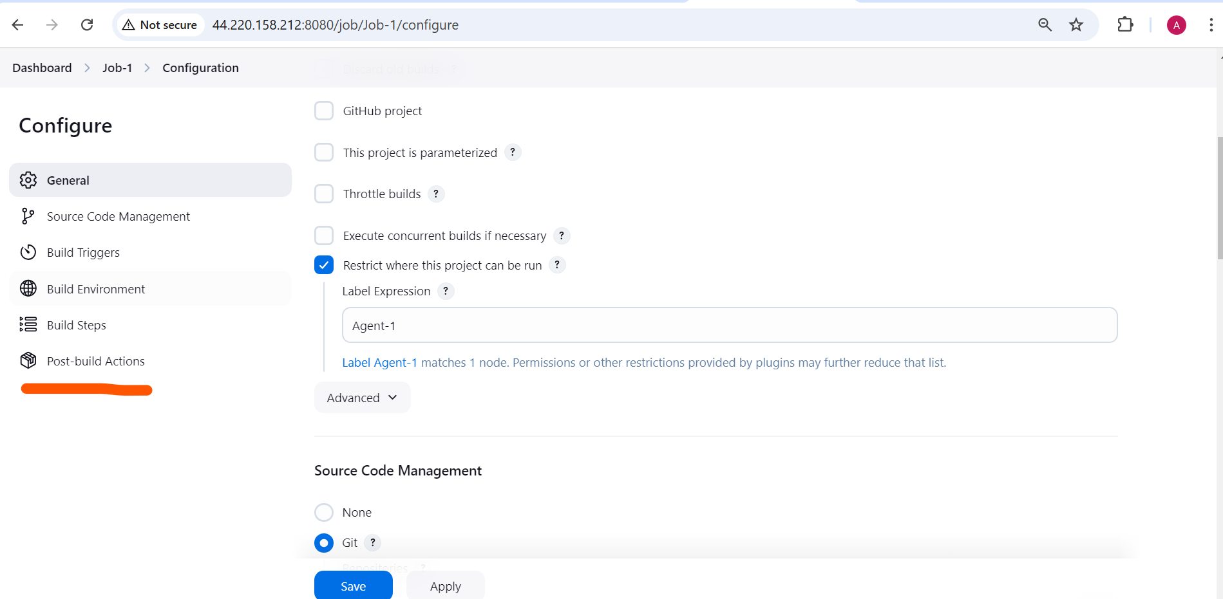

Select build other project

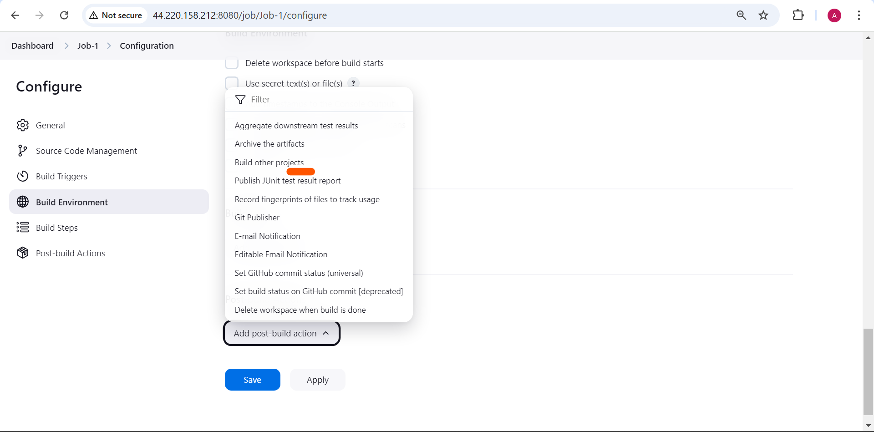

Trigger the Job-2 only if Job-1 successfully build

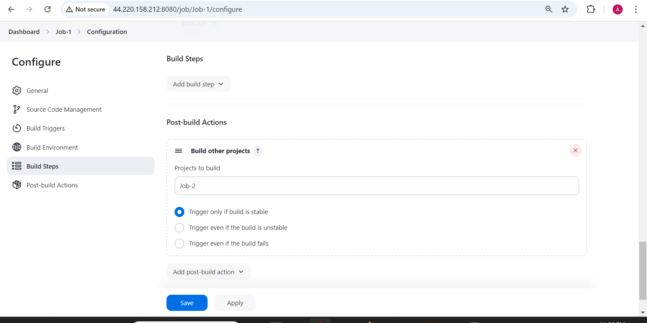

To test it

Got to the github account do change on the Develop branch so it will trigger the Job-1 and after Job-1 successfully completed it will automatically trigger the job-2

